

Mini Project Report – 06

Master of Computer Application – General Semester – I

Sub: Frontend Frameworks and Technologies

Topic: Portfolio Website using CSS Grid & Animations

By
Name: Ashraj Singh Rana
Reg no.: PROV/ASAC/MCA/7/26/058

Faculty Name: VEERA RAGHAV K

Faculty Signature:

Department of Computer Application Alliance University
Chandapura - Anekal Main Road, Anekal Bengaluru - 562 106
August 2026

INDEX

Fig No. | Name | Page No.
1. | Introduction | 1
2. | Input code | 2 – 10
3. | Output code | 11
4. | Conclusion | 12

INTRODUCTION
The My Portfolio is a simple and responsive webpage created using HTML and CSS. It is designed to introduce the developer and display important information such as an introduction, projects, skills, and contact details. HTML is used to create the structure of the portfolio, including sections, project cards, buttons, and the contact form. CSS is used to improve the appearance by adding colors, spacing, borders, hover effects, animations, and a responsive layout. The portfolio also uses a media query to make the webpage suitable for smaller screens such as mobile devices. This project helps in understanding the basic concepts of HTML, CSS, responsive design, animations, and webpage layout.

INPUT CODE
<!DOCTYPE html>
<html lang="en">

<head>
<meta charset="UTF-8">
<meta name="viewport" content="width=device-width, initial-scale=1.0">
<title>Ashraj Singh Rana | Portfolio</title>
<style>
body {
margin: 0;
font-family: Arial, sans-serif;
background-color: #f7f3f1;
color: #302b36;
}

header {
padding: 25px;
color: white;
background-color: #493044;
text-align: center;
animation: fadeIn 1.5s;
border-bottom: 5px solid #d47a62;
}

nav {
margin-bottom: 30px;
}

nav ul {
display: flex;
justify-content: center;
gap: 15px;
padding: 0;
list-style: none;
}

nav a {
color: white;
text-decoration: none;
}

nav a:hover {
color: #ffd08a;
}

.intro {
padding: 20px 0;
}

.intro h1 {
margin: 10px 0;
font-size: 36px;
}

main {
display: grid;
grid-template-columns: 1fr 1fr;
gap: 20px;
max-width: 1000px;
margin: auto;
padding: 25px;
}

section {
margin: 0;
padding: 25px;
background-color: white;
text-align: center;
animation: fadeIn 1.5s;
border-radius: 8px;
box-shadow: 0 2px 6px #00000014;
}

.about,
#projects {
grid-column: 1 / 3;
}

h2 {
color: #59394f;
}

.projects {
display: grid;
grid-template-columns: repeat(3, 1fr);
gap: 15px;
}

.card {
padding: 20px;
border: 1px solid #e6d7df;
border-left: 4px solid #d47a62;
background-color: #fffaf8;
transition: 0.3s;
}

.card:hover {
transform: scale(1.03);
background-color: #fbe9e2;
}

.button {
display: inline-block;
padding: 10px 15px;
border: 0;
color: white;
background-color: #bc5f50;
text-decoration: none;
cursor: pointer;
transition: 0.3s;
}

.button:hover {
background-color: #9e463e;
}

.skills-list {
display: flex;
flex-wrap: wrap;
justify-content: center;
gap: 12px;
padding: 0;
list-style: none;
}

.skills-list li {
padding: 10px 15px;
border: 1px solid #76a99c;
background-color: #e2f0ec;
transition: 0.3s;
}

.skills-list li:hover {
transform: scale(1.05);
}

form {
max-width: 400px;
margin: auto;
text-align: left;
}

label {
display: block;
margin-top: 12px;
}

input,
textarea {
width: 100%;
margin-top: 5px;
padding: 10px;
border: 1px solid #b9aeb8;
box-sizing: border-box;
}

textarea {
height: 100px;
}

.form-status {
color: #28735f;
}

footer {
padding: 15px;
color: white;
background-color: #493044;
text-align: center;
}

@keyframes fadeIn {
from { opacity: 0; }
to { opacity: 1; }
}

@media (max-width: 650px) {
main {
grid-template-columns: 1fr;
padding: 15px;
}

.about,
#projects {
grid-column: 1;
}

.projects {
grid-template-columns: 1fr;
}

nav {
margin-bottom: 20px;
}

nav ul {
flex-wrap: wrap;
gap: 10px;
}

section {
padding: 20px;
}

.intro h1 {
font-size: 28px;
}
}
</style>
</head>

<body>
<header>
<nav aria-label="Main navigation">
<ul>
<li><a href="#about">About</a></li>
<li><a href="#projects">Projects</a></li>
<li><a href="#skills">Skills</a></li>
<li><a href="#contact">Contact</a></li>
</ul>
</nav>
<div class="intro" id="home">
<p>Hello, I am</p>
<h1>Ashraj Singh Rana</h1>
<p>Student and Web Developer</p>
</div>
</header>

<main>
<section class="about" id="about">
<h2>About Me</h2>
<p>I am a student interested in web development and technology. I enjoy learning new skills and building
useful things for the web.</p>
</section>

<section id="projects">
<h2>My Projects</h2>
<div class="projects">
<article class="card">
<h3>College Event Website</h3>
<p>A simple website for sharing event details and schedules.</p>
<a class="button" href="#contact">Ask about project</a>
</article>
<article class="card">
<h3>Food Delivery Website</h3>
<p>A sample menu and ordering experience for a local restaurant.</p>
<a class="button" href="#contact">Ask about project</a>
</article>
<article class="card">
<h3>Student Management System</h3>
<p>A small project for organizing student information.</p>
<a class="button" href="#contact">Ask about project</a>
</article>
</div>
</section>

<section id="skills">
<h2>My Skills</h2>
<ul class="skills-list">
<li>HTML</li>
<li>CSS</li>
<li>JavaScript</li>
<li>Python</li>
<li>Java</li>
</ul>
</section>

<section class="contact" id="contact">
<h2>Contact Me</h2>
<form id="contact-form">
<label for="name">Name
<input id="name" name="name" type="text" required>
</label>
<label for="email">Email
<input id="email" name="email" type="email" required>
</label>
<label for="message">Message
<textarea id="message" name="message" required></textarea>
</label>
<div>
<button class="button" type="submit">Send Message</button>
</div>
<p class="form-status" id="form-status" aria-live="polite"></p>
</form>
</section>
</main>

<footer>
<p>&copy; 2026 Ashraj's Portfolio</p>
</footer>

<script>
document.getElementById("contact-form").addEventListener("submit", function (event) {
event.preventDefault();
document.getElementById("form-status").textContent = "Thank you for your message!";
document.getElementById("contact-form").reset();
});
</script>
</body>

</html>

OUTPUT
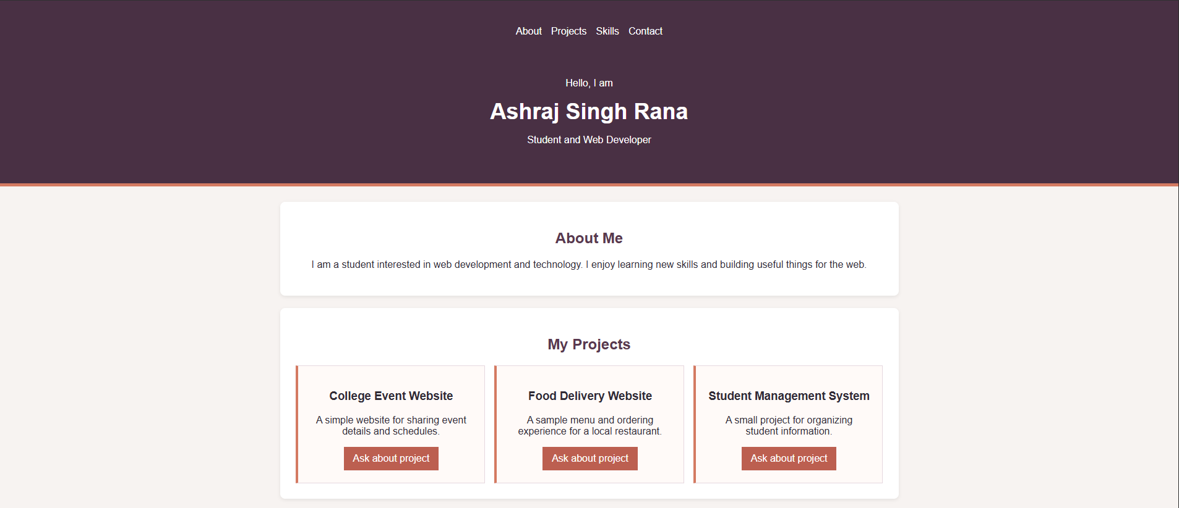
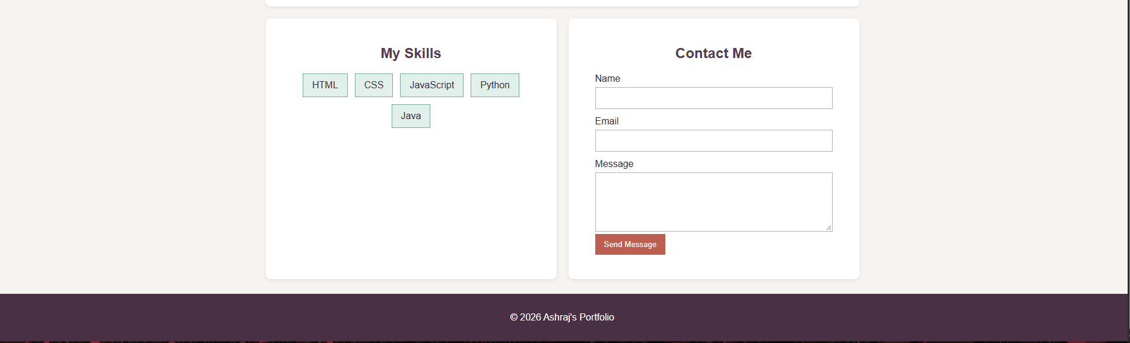

CONCLUSION

The My Portfolio project successfully demonstrates how HTML and CSS can be used to create a simple, attractive, and responsive personal webpage. The portfolio includes sections for About Me, Projects, Skills, and Contact Me, which help present the developer's information in an organized way. HTML is used to create the structure, while CSS is used for colors, spacing, buttons, hover effects, animations, and layout. The responsive design ensures that the webpage works properly on different screen sizes. Overall, this project provides a basic understanding of web development, CSS styling, animations, forms, and responsive webpage design.

